

**F. Y. B. Tech Academic Year 2021-22 ECE1022A: Basics of Electrical and Electronics Engineering**

**Trimester: II , Sem 1 Assignment 1**

**Subject:** Basics of Electrical and Electronics Engineering **Trimester: I**

**Name:** Shreerang Mhatre **Division: 11**

**Roll No:** 111056 **Batch: K3**

**Date: 10 Jan 2022 Max. Marks: 25 Submission Date: 17 Jan2022 Course Outcomes (COs) Covered:**

1. Predict the behaviour and characteristics of basic electrical and magnetic circuits. (CLII) 2. Identify components/equipment required for any particular application related to electrical and electronics engineering. (CL-II)

**Instructions:**

1. **Q I is a set of 10 MCQs. Each MCQ carries one mark.**
2. **Q II, Q III, Q IV each carry 5 marks.**
3. **Pls note in Q II, Q III, Q IV, the component values are to be selected based on your division and roll number.**

**Q. I Select the answer of the following MCQs.**

1. When transistor is used as an amplifier, it operates in the

ANS: A. Active region

1. Select which statement is incorrect.

ANS: B. If the external reverse-bias voltage is increased to a value called the breakdown voltage, the reverse current will drastically decrease.

3)If VCC = +15 V, then in the voltage-divider circuit with resistor R1 is 4.7 k, and R2 is 1500, what is the base bias voltage for a transistor in CE configuration?

ANS: C 3.62 V



4) Select the correct statement from the following**:**

ANS: A. In PNP BJT, a collector is heavily doped and base is lightly doped

5)When the collector junction in transistors is reverse biased and the emitter junction is reverse biased, the transistor is said to be operating in the

ANS: A. Cut off region

1. In a BJT of type NPN, the largest current flows.

ANS: D. In the emitter

1. Select the incorrect statement.

ANS: C. Zener diodes are used in forward biased condition for an application of voltage regulator.

1. What is the current gain for a common-base configuration where IE = 4.2 mA and IC = 4.0 mA?

ANS: D. 0.95

1. Which of the following statements is incorrect?

ANS: B. The Energy difference between the electrons and the holes corresponds to the energy of

visible light.

1. Which of the following statements is incorrect?

ANS: B. CE arrangement with output shorted



# Q. II A voltage V(t) = 300 cos 100ωt is applied to a half wave rectifier with RL =5KΩ. The rectifier is

# represented by an ideal diode in series with a resistance of a value equal to the last two digits of roll

# no. of a student (For example- 1KΩ, 2KΩ ,3KΩ…….65KΩ )

# Find the following:

# 1. Load Current ( Im )

# 2. DC Power

# 3. AC Power

# 4. Rectifier efficiency

# 5. Ripple factor

# 

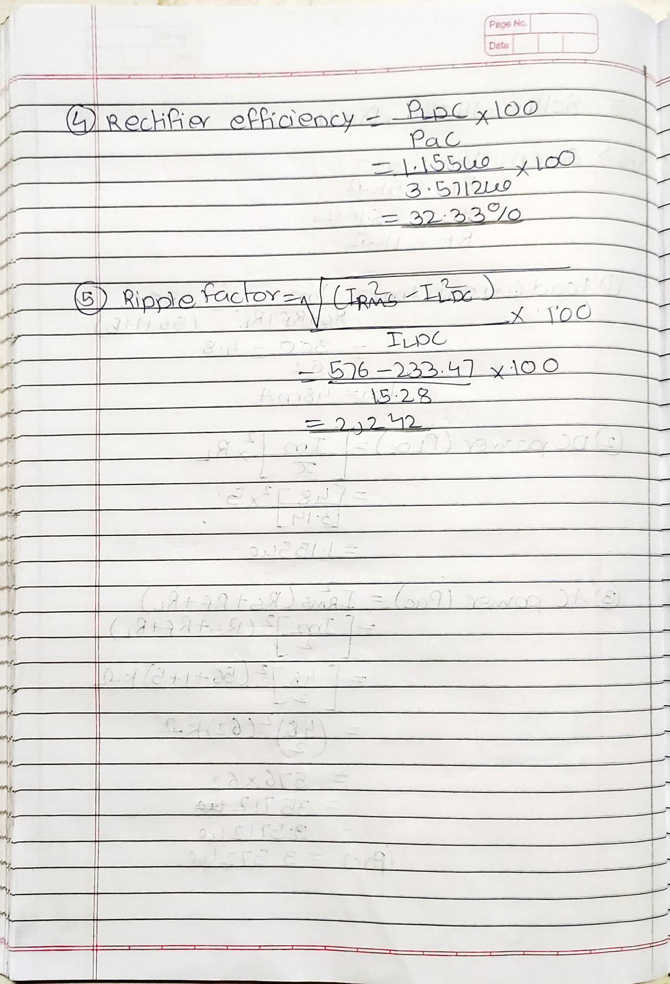





## (Example) Lets take Roll Number 111003 (for div 11)

*Vz= (0+3)= 3 volts Vs= (2*3)+2= 8 Volts*

*Pz= Division no. 11 > 10 so 11-5=6 Watts*

Using the Zener regulator circuit shown below, calculate:

* 1. The maximum current flowing through the Zener diode**.**
  2. The value of the series resistor, Rs, with no load
  3. The load current IL if a load resistor of 1kΩ is connected across the Zener diode.
  4. The Zener current Iz at full load.

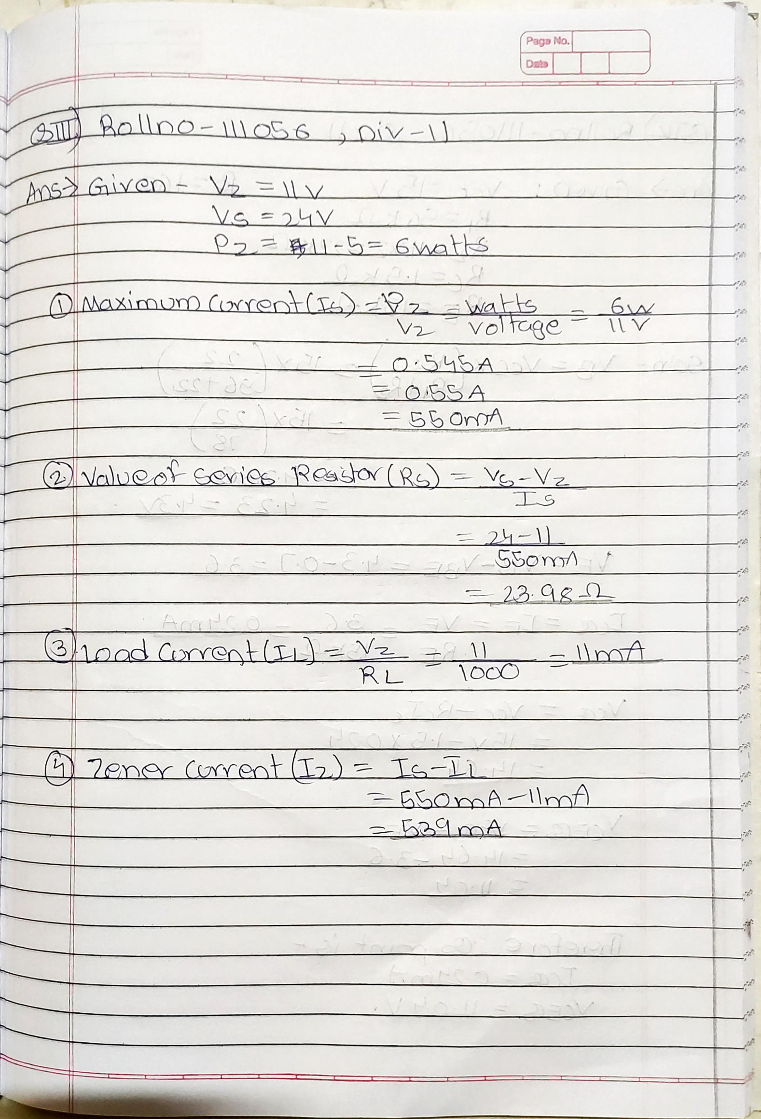



# Q IV.

A silicon transistor connected in CE configuration with voltage divider bias is shown in the following figure. VCC =15V,

R1 is equal to twice of the last two digits of your roll number in KΩ if those two digits are less than 35(roll no.1- roll no. 34) (Ex: for 1110**12**, R1=2\***12**=24KΩ) else the last two digits in KΩ,

R2 is equal to thrice of your division number for students with roll number less than 35 (roll no.1- roll no. 34) and twice of your div no. for students with roll no. greater than and equal to 35.

(Example for div 11: For roll no. 1**11**012, R2=3\***11**=33K & for roll no. 1**11**070, R2=2\***11**=22KΩ). Find the Q-point of the amplifier circuit if Rc=1.5KΩ & RE=15KΩ &

β = 160

Refer the following circuit diagram below for R1,R2 Rc ,RE and Vcc.

